Fancy Font Clock (v2.0)

General Info
The Fancy Font Clock (v2.0) is a digital clock that displays the time/date using truetype style bit-mapped fonts instead of the seven-segment display used by most digital clocks. It gets the time/date information from your WiFi. As such it automatically adjusts for daylight/standard time changes per your WiFi service provider. Version 2.0 includes software changes to overcome a C programming language limitation when multiple time structures are used (GMT and local), more control over display brightness, and better auto-dimming at night.

Setup
- Connect Power: The clock receives power from a 5V 3A micro-USB AC adapter. The micro-USB connector is slightly wider on the top than the bottom. Before plugging the AC adapter into the wall, plug the micro-USB power cable into the rear of the clock under the “PWR” label.

Note: I find it easier to plug in the micro-USB cable by first laying the clock face down.

- Connect Keyboard: The keyboard is only required for WiFi setup or changing clock options, otherwise it should be left unconnected. Connecting a USB keyboard requires a micro-USB to USB type A female keyboard adapter cable. The micro-USB connector is slightly wider on the top than the bottom. Plug the micro-USB end of the keyboard adapter cable into the rear of the clock under the “USB” label. Plug a USB keyboard into the USB type A end of the keyboard adapter cable.

Note: I find it easier to plug in the micro-USB cable by first laying the clock face down.

- WiFi Setup: The WiFi setup only needs to be done if the WiFi changes. Relocating the clock in your house does not require redoing the WiFi setup. Have ready your WiFi name and password, remember they are case sensitive! Plug in the AC adapter. Once the clock finishes booting (~1 minute) it will display a time, most likely the incorrect time as the clock has yet to connect to a WiFi.
  - Type: <Ctrl> C
  - The display should now show the raspberry pi prompt:
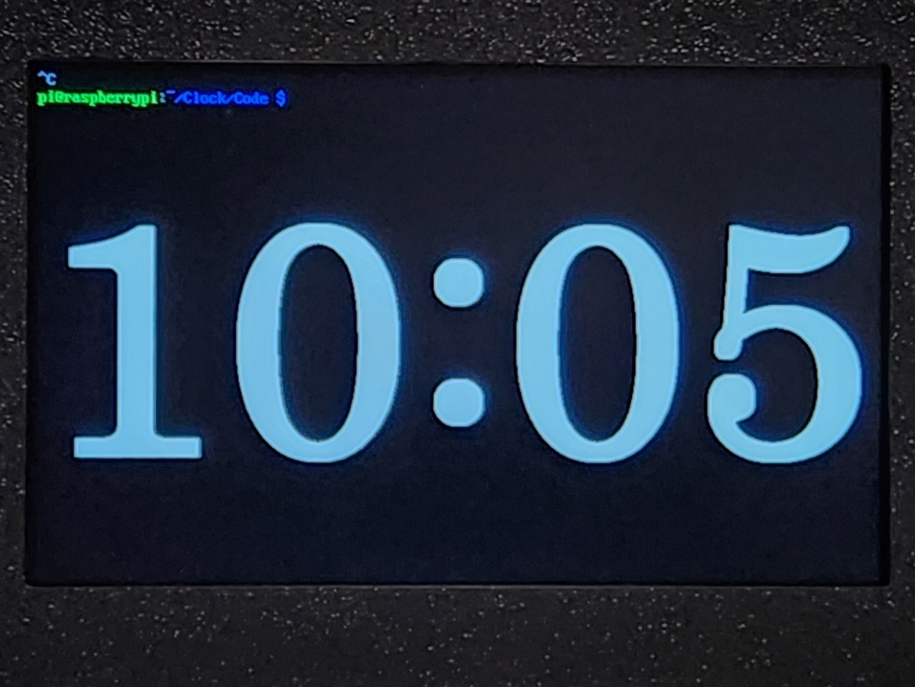
  - Enter: sudo raspi-config
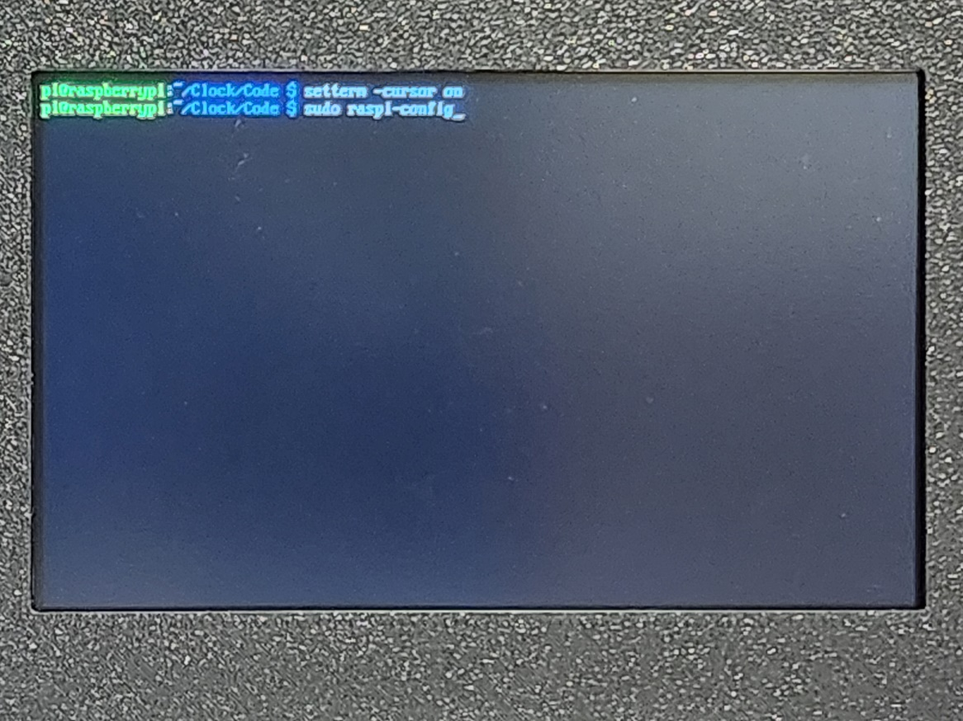
  - Using the arrow keys, highlight “System Options” and press Enter
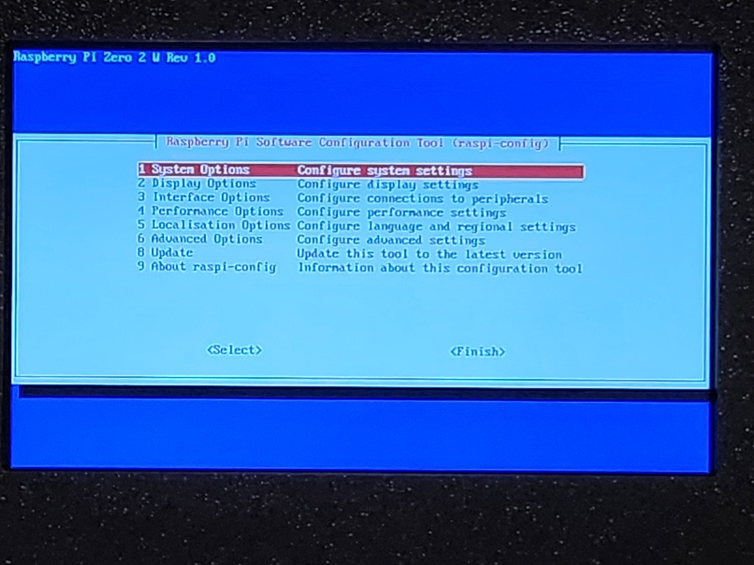
  - Using the arrow keys, highlight “Wireless LAN” and press Enter
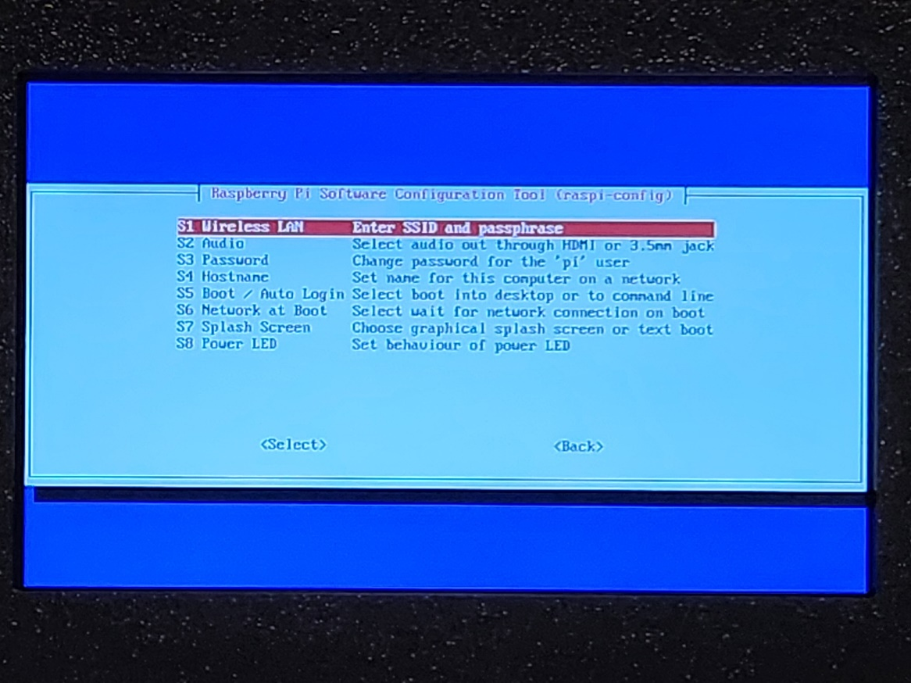
  - Enter your WiFi name, remember case sensitive!
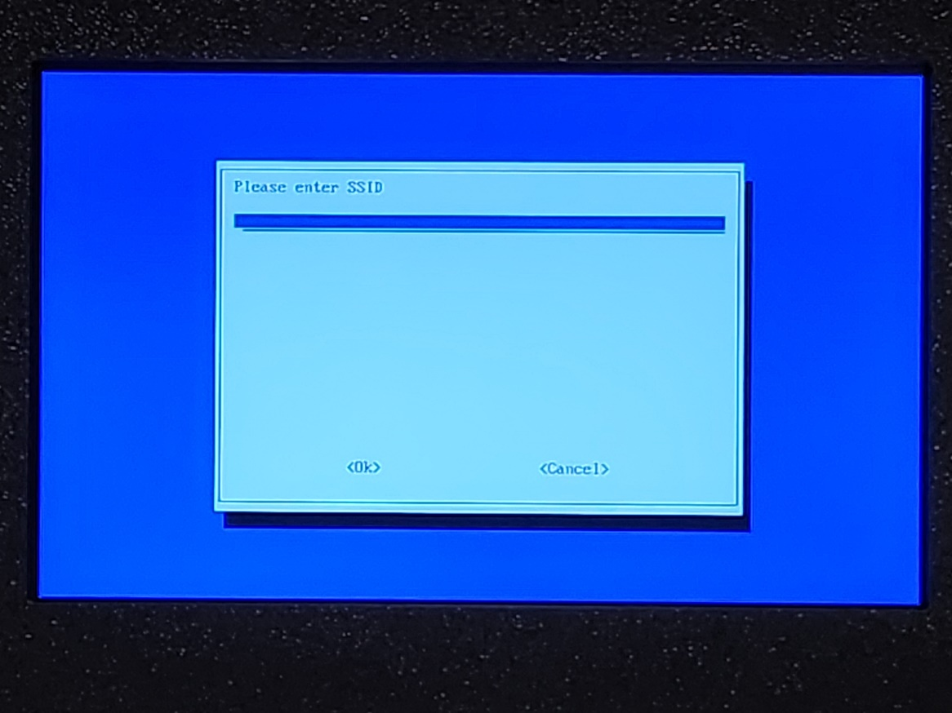
  - Enter your WiFi password, remember case sensitive!
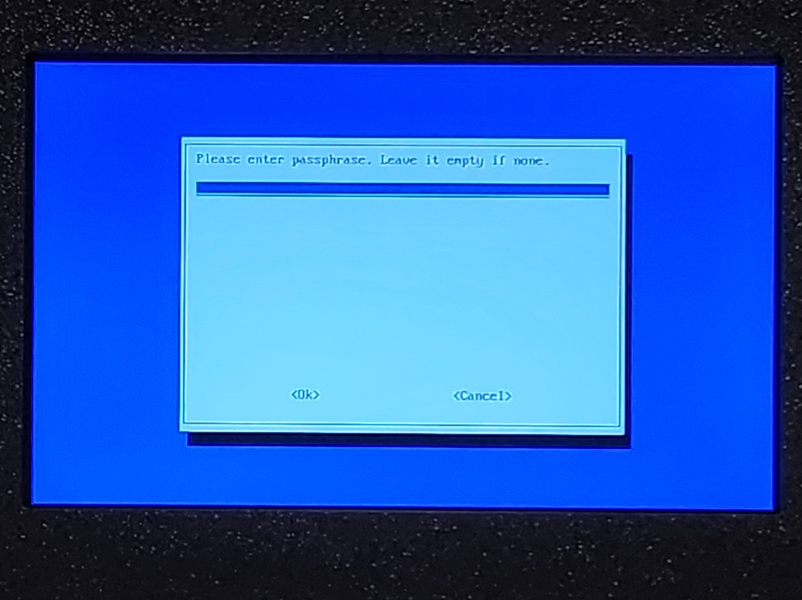
  - Using the arrow keys, highlight “<Finish>” and press Enter
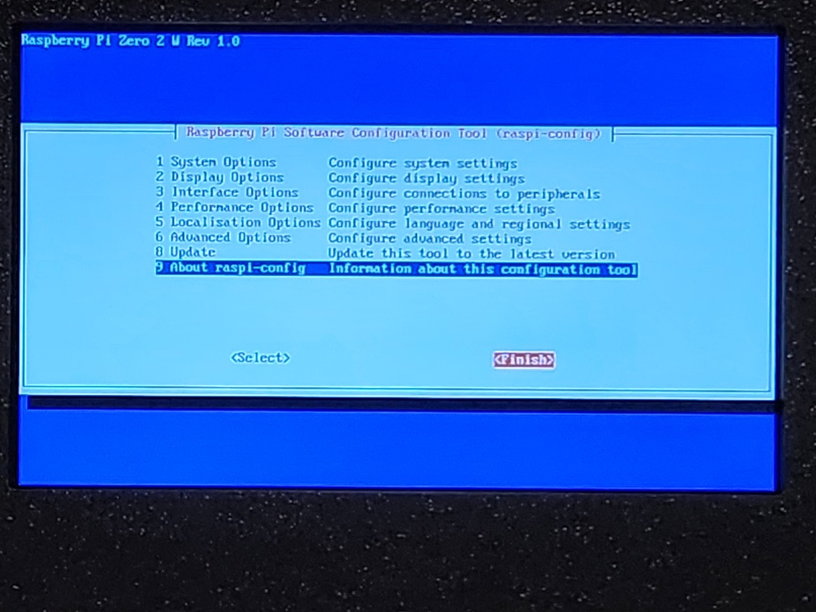
  - Enter sudo ./clock
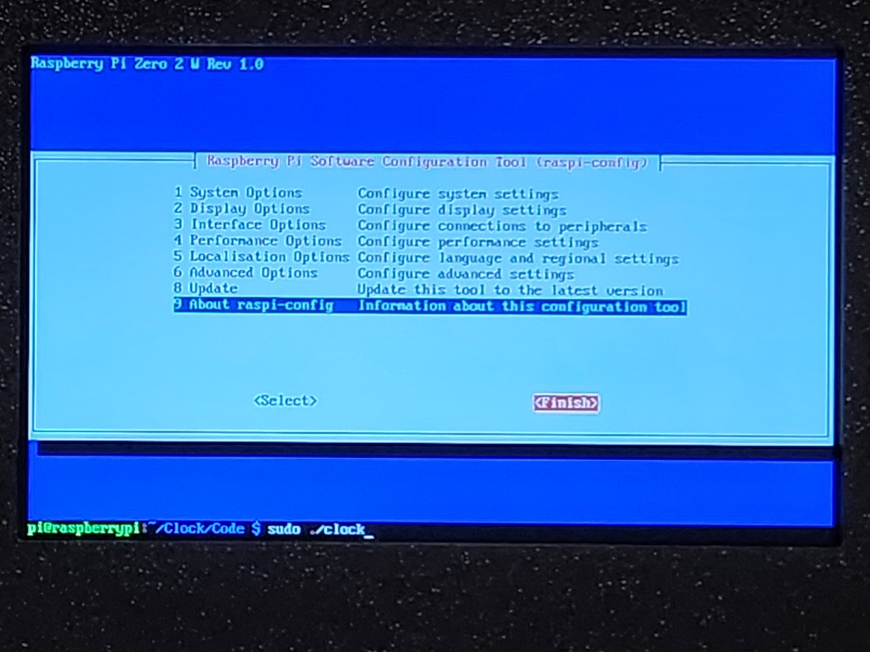
  - The hardware startup screen will be displayed for 3 seconds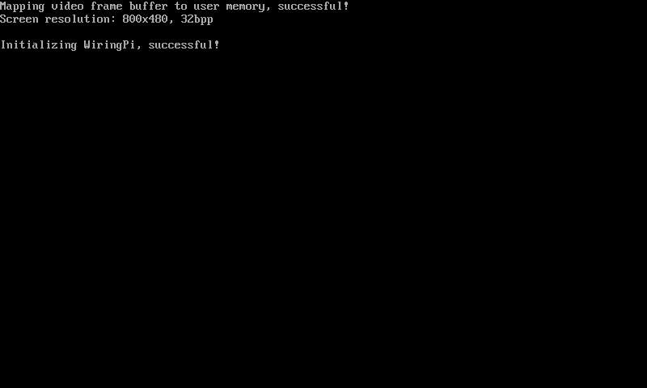

  - The software version/startup screen will be displayed for 7 seconds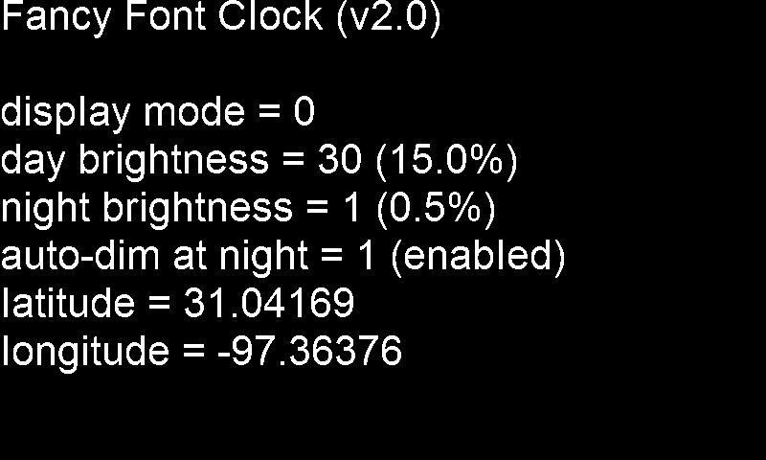

  - Then the time will be displayed

Note: It may take up to 2 minutes for the current time to be displayed.


- Optional Settings: The Fancy Font Clock has a few options including:
- Different display modes
- Day brightness
- Night brightness
- Automatic dimming at night
- Latitude and longitude
Making changes to these options requires some minor editing of the options.h file.
Note: If you want to activate display mode 5 and/or automatic dimming at night you’ll need to know the clock’s latitude and longitude. This is easily obtained using Google Maps on your computer. Navigate to where the clock is placed. Zoom in to the maximum. Point the cursor at the clock’s location, and right click. A small dialog box will appear. The top line contains the latitude and longitude information. Write down both these numbers.
  - Type: <Ctrl> C
  - The display should now show the raspberry pi prompt:

  - Enter: sudo nano options.h
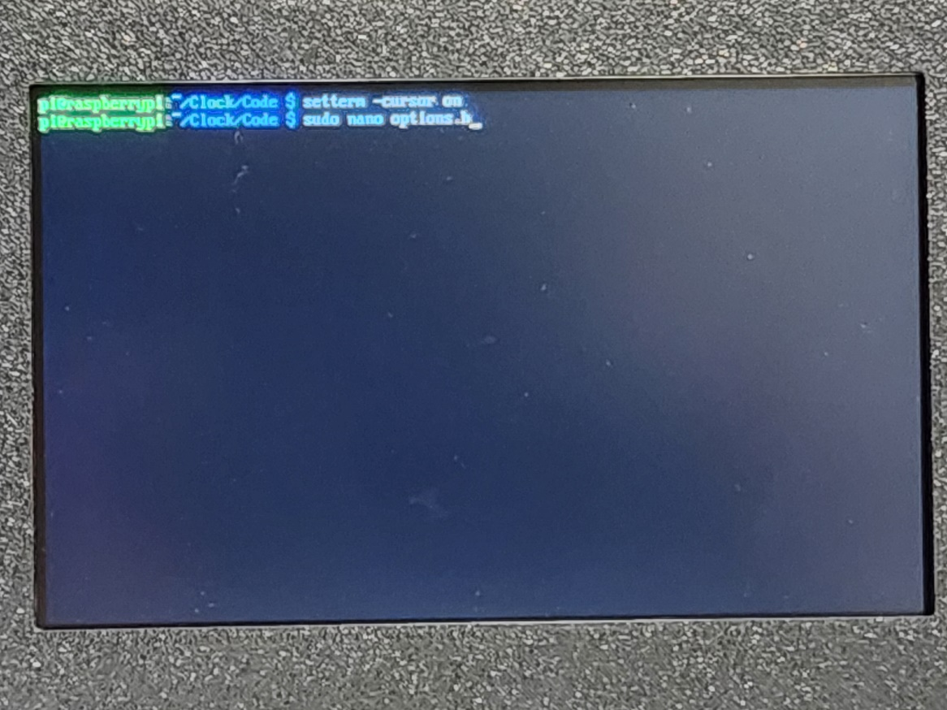

  - An editing screen will be displayed
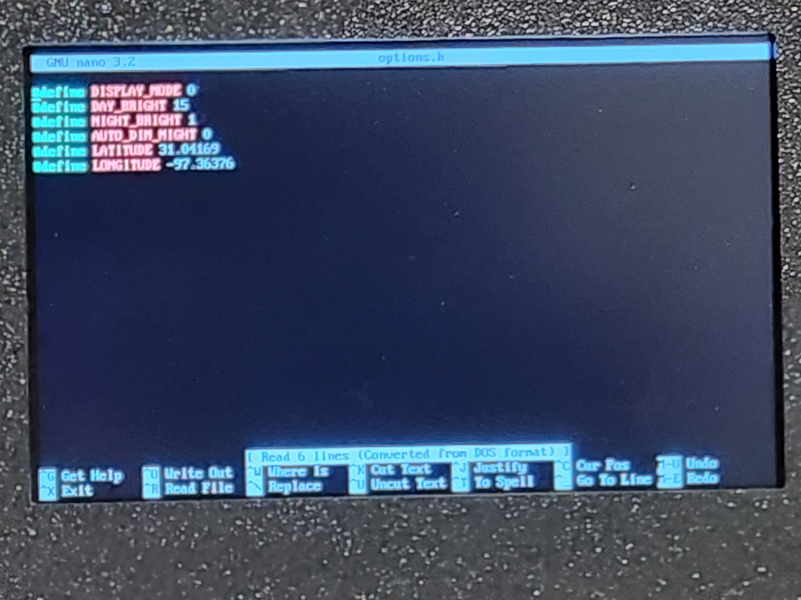
  - To change the display mode, use the arrow keys to move the cursor to behind the value after “#define DISPLAY_MODE” then press backspace to erase the old value and type in a new value.

Note: Only integer values defined in this document (0 to 5) are valid.

  - To change the day brightness, use the arrow keys to move the cursor to behind the value after “#define DAY_BRIGHT” then press backspace to erase the old value and type in a new value.
Note: Only values between 1 and 200 (0.5% to 100%, in 0.5% increments) are valid.

  - To change the night brightness, use the arrow keys to move the cursor behind to the value after “#define NIGHT_BRIGHT” then press backspace to erase the old value and type in a new value.
Note: Only values between 1 and 200 (0.5% to 100%, in 0.5% increments) are valid, and the night brightness cannot be greater than the day brightness.

  - To enable/disable automatic dimming at night, use the arrow keys to move the cursor to behind the value after “#define AUTO_DIM_NIGHT” then press backspace to erase the old value and type in a non-zero value (ex. 1) to enable, or 0 to disable.
Note: The automatic dimming function linearly adjusts the brightness from night to day between morning nautical twilight and sunrise, and from day to night between sunset and evening nautical twilight.

  - If you want display mode 5 and/or automatic dimming at night to work correctly, you’ll need to include the clock’s location.

Note: Finding the clock’s location is easily obtained using Google Maps on your computer. Navigate to where the clock is placed. Zoom in to the maximum. Point the cursor at the clock’s location, and right click. A small dialog box will appear. The top line contains the latitude and longitude information.

Use the arrow keys to move the cursor to behind the value after “#define LATITUDE” then press backspace to erase the old value and type in a new value. Use the arrow keys to move the cursor to behind the value after “#define LONGITUDE” then press backspace to erase the old value and type in a new value.
  - Once you’ve made all your changes, type: <Ctrl> X
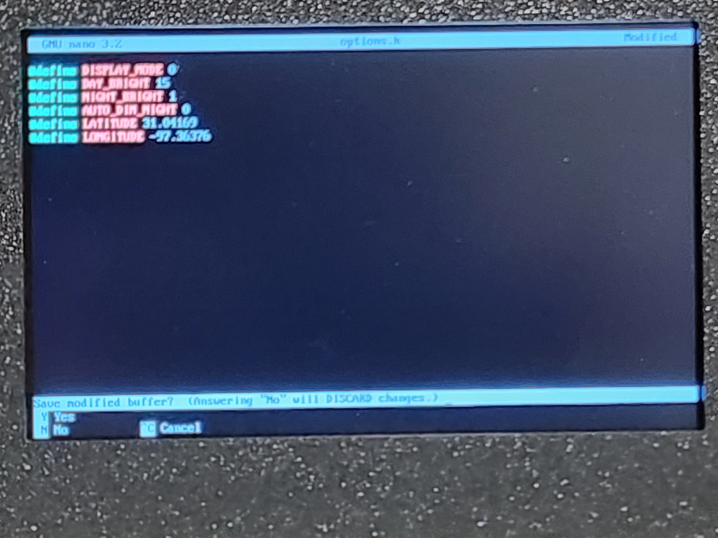
  - You’ll be asked if you want to save the changes you’ve made, type: Y and press Enter
  - Enter: sudo ./clock
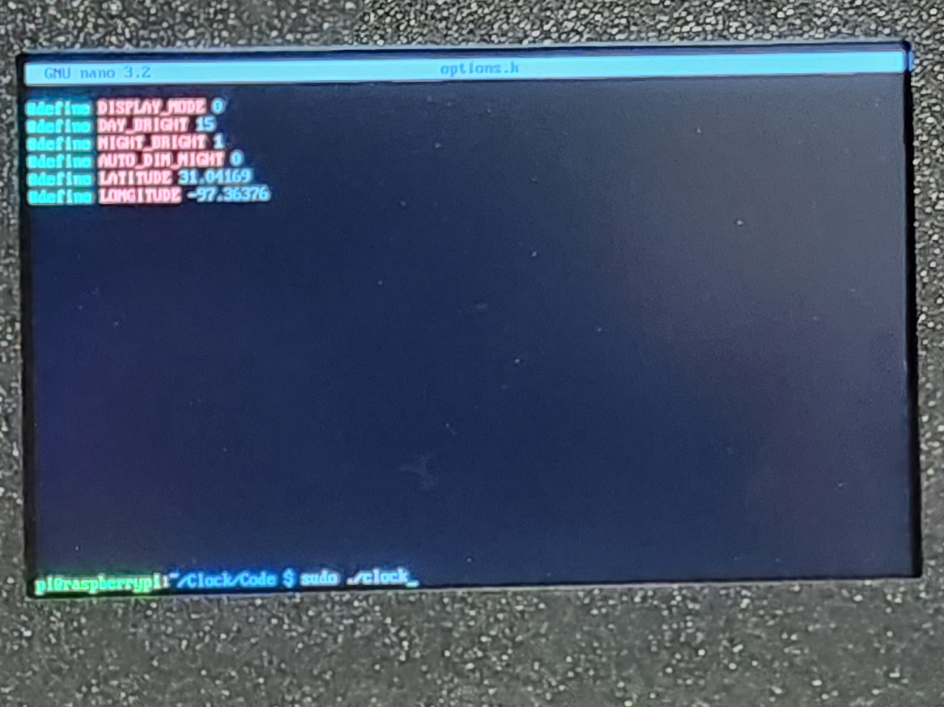
  - The hardware startup screen will be displayed for 3 seconds

  - The software version/startup screen will be displayed for 7 seconds

  - The time will be displayed

Note: It may take up to 2 minutes for the current time to be displayed.


- Display Options:
  - Display mode 0

  - Display mode 1
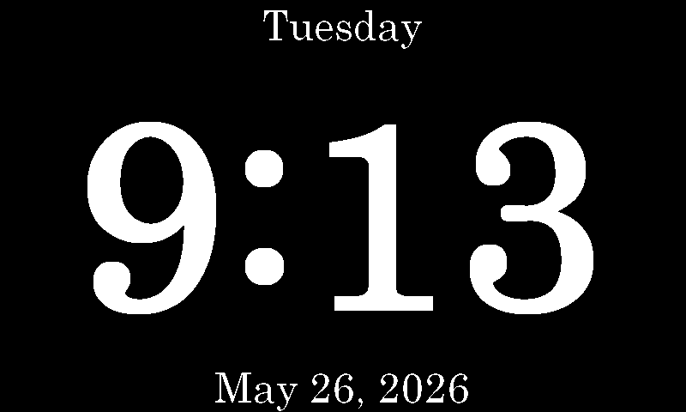
  - Display mode 2
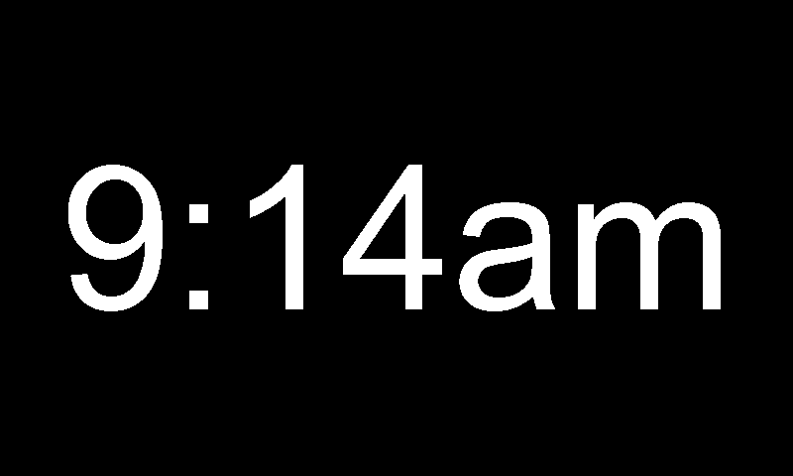
  - Display mode 3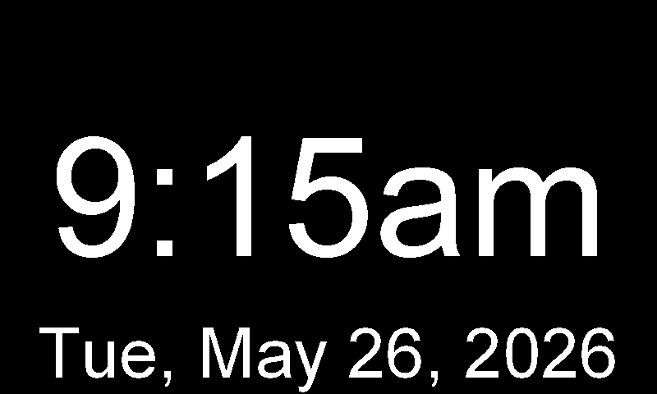
  - Display mode 4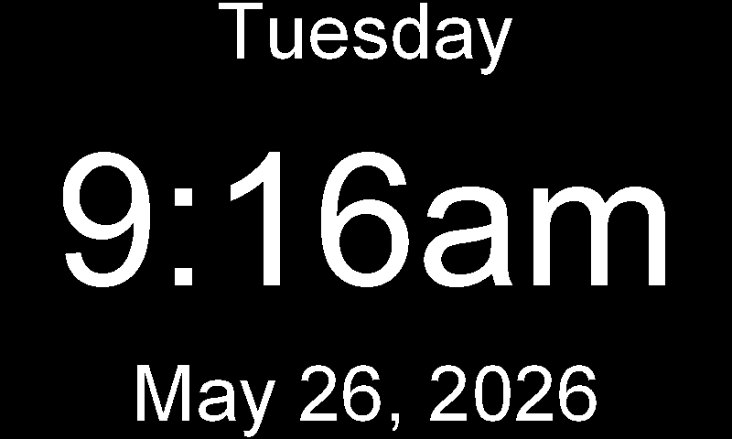
  - Display mode 5
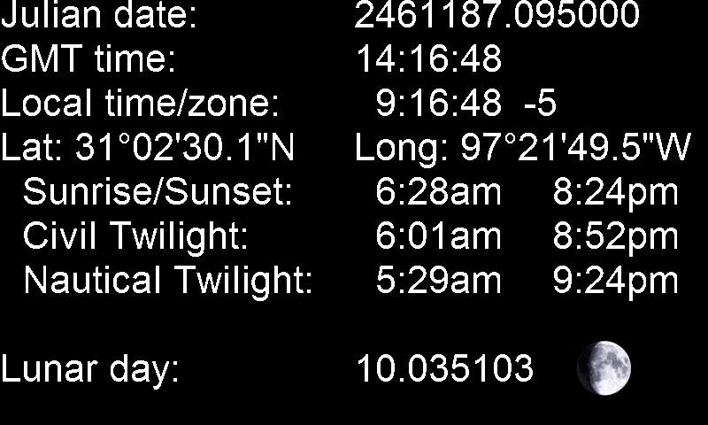

Background Story
I actually began this project back in 2020. Back then I decided I wanted a digital clock that would get the time from the internet, automatically adjust for standard/daylight time, and dim at night so it could be used in the bedroom. I search the internet (Amazon, etc.) and found nothing provided those features. So, I began working to come up with my own solution. I began researching embedded processors and quickly selected ARM (it’s used in nearly every smart phone). I spent 2020 looking into graphics libraries for ARM, and selected one called OpenGL. About 6 months after I started writing code, I learned that OpenGL was no longer supported, and that all the other graphics libraries didn’t make it easy for one program to control the entire display, they were all designed around daughter windows. I realized I would first have to come up with my own graphics library. I procrastinated for over a year before forcing myself to start writing one.
I started with a Raspberry Pi 3B+, an ARM processor with 512MB of RAM and an HDMI output. It took about a month to figure out how to make the HDMI output 24-bit color and to map the entire display memory (32-bits per pixel) into user memory that an ARM assembly language program could access.
I finally started writing my Simple ARM Graphics Library (SAGL) in early February 2022 using ARM assembly code. By the middle of March, I had a fundamental working library that could draw lines, rectangles, circles, and print the 96-character ASCII text (in a couple of fonts). It’s easy to use in C programs without any unique system calls. It has been improved with error checking to prevent attempts that would try to draw outside the display boundaries causing segmentation faults. Some additional features have been added: printing strings left/center/right justified, displaying BMPs, get/set an individual pixel color, and functions making it easy for a C program to determine the text height and string length in pixels using the selected font. All fonts have been expanded to use the entire 256-character set. I’ve also added several fonts of fixed size (I couldn’t figure out how to process either TrueType or OpenType font file formats). The SAGL is currently at version 1.3 and is available on GitHub (search for “Simple ARM Graphics Library”). I’ve set it up as public domain software (no license required to use).
The Fancy Font Clock code is written in C and uses the Simple ARM Graphics Library (SAGL) for displaying time, date, day, etc. It has been developed for a small 5” LCD (800 x 480, 32-bits per pixel). The code was developed in parallel with a weather station project I was also working on since 2022, so there was some code leakage between them (i.e. some features for each were derived from the other, see clock mode 5 for an example).

If you were to open the case, all you’d find is a Raspberry Pi Zero 2 W computer board (user: pi, password: FancyFontClock), an NHD-5.0-HDMI-N-RTXL LCD display, and three cables between them (LCD power cable, LCD HDMI signal cable, LCD PWM brightness control cable). The hardware design configuration has been stable since mid-2023, but resources for designing a case didn’t become available to me until August 2025.
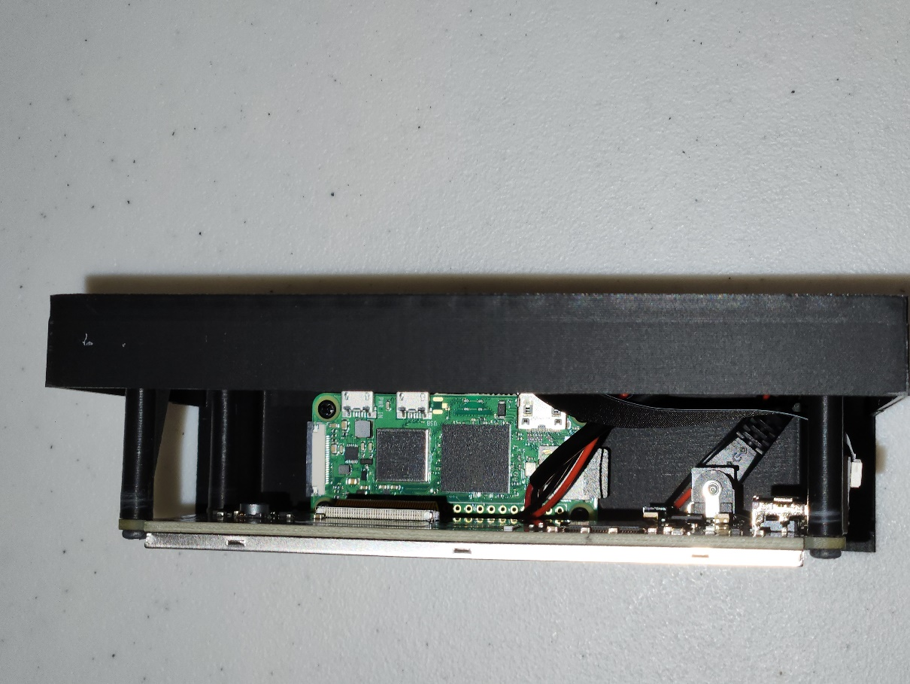

Credits
Hardware/Software Engineer:
Paul Weber
Temple, TX

First Mechanical Engineer:
Jayben Scalph
Spokane Valley, WA

Second Mechanical Engineer and 3D Printing:
Will Dalziel
Willd Designs & 3D Printing LLC
5819 E. US 190
Temple, TX 76501
254-677-6337
https://www.willddesigns.com/

